Spectral reflectance of soils

Ivan Bergier Tavares de Lima ^{1,2}
Evlyn Márcia Leão de Moraes Novo ²
João Antonio Lorenzzetti ²

1 Universidade de São Paulo - USP/CENA
Caixa Postal 96 - 13416-000 - Piracicaba - SP, Brasil
ivan@xxx.exemplo.br

2 Instituto Nacional de Pesquisas Espaciais - INPE
Caixa Postal 515 - 12245-970 - São José dos Campos - SP, Brasil
{evlyn, loren}@xxx.exemplo.br

Abstract. This meta paper describes the style to be used in papers for the XVI SBSR. It serves as a model to be used by the authors when preparing their papers. The Abstract is very important. It is the first part of your paper to be read by the scientific community; it is the first impression concerning your work. Please, state clearly the problem, hypotheses and objectives. Describe the rationale and methodology. Report the main results, and conclusions. Do not use automatic translation; in general, the result can be very poor and may severely influence negatively the acceptance of your paper. Before sending the paper, revise the whole text carefully. The Abstract for this Symposium must be between 200 and 250 words. Not too short, not too long. As a reference, this text has 141 words. Please, do not paginate your manuscript.

Keywords: Remote Sensing, Image Processing, Geology.

1. Pages
Do not paginate your PDF manuscript. The text must be written in 12 points (pt) using Times New Roman font. Use single space between lines in the entire text.
The document must be at A4 format, with the following margins: above 3cm, below 2cm, at left 2,5cm and at right 2,5cm. The text shall be formatted in just one column.
The total number of pages (including figures, tables, formulas and references) is limited to 8 (eight) for full papers and works of scientific initiation. These papers, if approved by the Committee, can be presented in Technical Sessions or Interactive Poster Sessions, according to the choice of the Committee.
The first page must contain the title of the work, full name, address and e-mail of all the authors, the Abstract and Keywords.
The title of the paper must be centralized, in lower case (except for the initial letter of the first word from the title, use the acronym or the initials of names), in bold and 12 pt.
The names of authors, addresses and the e-mail must be centralized and at 12 pt; and only the initials of each name should be in capital letters.
The names of authors must be written in full (without any abbreviation). This is necessary in order to avoid duplicates in the Table of Contents at the Proceedings and for indexing purposes.
After each address, write the E-mail of the authors.
The electronic addresses mentioned in the text must be edited without hyperlinks, because these will not be recovered after the conversion to the PDF format.

1.1 Papers written in a foreign language
The papers may be written in English or Spanish. It is mandatory that foreign works are written in one of these two languages.
2. Sections and Paragraphs
The Organizing Committee suggests the following structure of sections to the papers:
Abstract
1. Introduction
2. Methodology
3. Results and Discussion
4. Conclusions
Acknowledgements
References
The title of each section or sub-section (e.g., 2.3.1) must be in bold. Use a simple spacing before the title. Sections must be numbered.
At all paragraphs there must be an indentation space of 0.7cm. There should not be any additional space between the paragraphs.
The Abstract must be written at 10 pt, preceded by the word “Abstract” in bold and have at least 200 and at most 250 words. The Abstract must be informative, and present the most important points of the text, related with the problem, the objectives, the methodology, the results and the conclusion. It shall be written in just one paragraph. It will be an important criterion for the acceptance of the paper.
The Keywords must be written in English, on 10 pt, using lower case (except for acronyms or names). Use four to six keywords which are not in the title of the paper.

3. Tables, Figures and Equations
The tables, figures and equations must be numbered in Arabic numbers. All calls of tables, figures and equations in the text must be mentioned, such as e.g. Figure 1, Table 1, Equation 1, etc.
In tables, the title must be inserted at its upper part.
In figures, the legends (or Source) must be inserted at its lower part..
In equations, the numbering must be presented, between brackets at the right margin of the equation.

3.1 Example of a Table
The size of each area and the average percentage of the area occupied by coffee are shown in Table 1.

Table 1. Lower and upper borders of strata, area of stratum, and average percentage of area planted with coffee.
Stratum | Border of stratum |  | Area of stratum | Average percentage of area
 | lower | upper | (km²) | used for coffee plantation
1 | 0,1 | 10,0 | 8.227 | 4,30
2 | 10,1 | 20,0 | 9.352 | 12,67
3 | 20,1 | + | 7.056 | 22,50
4 | 0,0 | 0,1 | 245 | 0,03

3.2 Example of Figure
The strata are presented in Figure 1, where one can observe the changes of the region with coffee plantations.

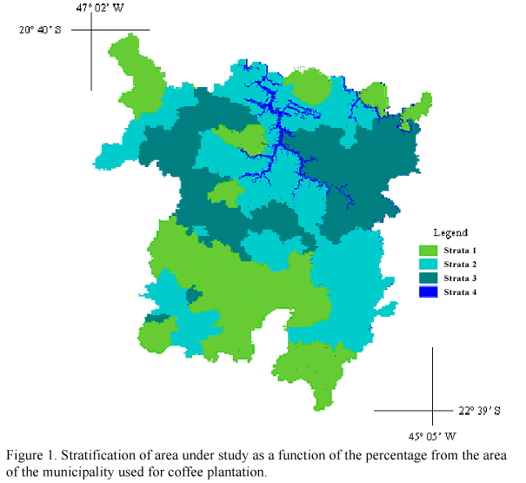

3.3 Example of equation
For the estimation of the area occupied with coffee, the model of direct expansion was used (Equation 3):

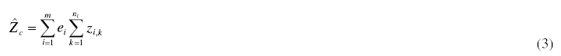

4. Citations and References
References must be complete and uniform. They must be written in 10 pt and separated by a single space line. In the text, the citations must be written as follows:
(a) one author: Almeida Filho (2002);
(b) two authors: Mascarenhas e Correia (1983);
(c) more than two authors: Novo et al. (2005).

References examples are presented below.

4.1 Paper in journal
Almeida Filho, R.; Shimabukuro, Y. E. Detecting areas disturbed by gold mining activities through JERS-1 SAR images, Roraima State, Brazilian Amazon. International Journal of Remote Sensing, v. 21, n. 17, p. 3357-3362, 2000.

4.2 Book
Florenzano, T. G. Imagens de satélites para estudos ambientais. São Paulo: Oficina de Textos, 2002. 97 p.

4.3 Book Section
Kampel, M.; Gaeta, S. A. Estimativa da produtividade primária oceânica. In: Rudorff, B. F. T.; Shimabukuro, Y. E.; Ceballos, J. C. (Org.). O sensor MODIS e suas aplicações no Brasil. São José dos Campos: Editora Parêntese, 2007. cap. 20, p.277-294.

4.4 PhD and MSc. Thesis
Boggione, G. A. Restauração de imagens do satélite Landsat-7. 2003. 160 p. (INPE-10462-TDI/929). Dissertação (Mestrado em Sensoriamento Remoto) - Instituto Nacional de Pesquisas Espaciais, São José dos Campos. 2003.

4.5 Conference Papers
Novo, E. M. L. M.; Barbosa, C. C. F.; Freitas, R. M.; Melack, J.; Shimabukuro, Y. E.; Pereira Filho, W. Distribuição sazonal de fitoplâncton no Lago Grande de Curuai em resposta ao pulso de inundação do Rio Amazonas a partir da análise de imagens MODIS. In: Simpósio Brasileiro de Sensoriamento Remoto (SBSR), 12., 2005, Goiânia. Anais... São José dos Campos: INPE, 2005. Artigos, p. 3175-3182. CD-ROM, On-line. ISBN 85-17-00018-8. Disponível em: <http://urlib.net/ltid.inpe.br/sbsr/2004/11.19.19.44>. Acesso em: 07 ago. 2006.

Oliveira Júnior, H. J.; Shimabukuro, Y. E. Mapeamento da cobertura da terra dos Estados do Goiás e Tocantins utilizando imagens do sensor MODIS. In: Simpósio Brasileiro de Sensoriamento Remoto (SBSR), 12., 2005, Goiânia. Anais... São José dos Campos: INPE, 2005. Artigos, p. 1641-1648. CD-ROM, On-line. ISBN 85-17-00018-8. Disponível em: <http://urlib.net/ltid.inpe.br/sbsr/2004/11.21.17.27>. Acesso em: 07 ago. 2006.

4.6 Technical Report
Mascarenhas, N. D. D.; Correia, V. R. M. Medidas de qualidade de estimadores de proporções de classe dentro de um pixel de imagem de satélite. São José dos Campos: Instituto Nacional de Pesquisas Espaciais, 1983. 52 p. (INPE-2791-PRE/354).

4.6 On-line Documents
Advanced Spaceborne Thermal and Reflection Radiometer (ASTER). Disponível em: <http://asterweb.jpl.nasa.gov/default.htm>. Acesso em: 15.jan.2003.

Hook, M.A.S.; Ramachandran, B. ASTER User Handbook Version 2. Pasadena: JPL/EROS Data Center/NASA, 1999. Disponível em: <http://asterweb.jpl.nasa.gov/content/03_data/04_documents/aster_user_guide_v2.pdf>. Acesso em: 16.set. 2005.

